Press Release

January 2020

Zund at Fespa '20 – standardized data preparation, versatile cutting

Zund digital cutting systems offer a unique variety of processing methods for a wide range of materials. At Fespa 2020 in Madrid, Zund will present a wide range of options for print service providers and advertising professionals to automate their Print&Cut workflow.

Zund digital cutting systems are the undisputed masters of application variety and efficiency. The modular concept that characterizes the entire range and the numerous automation solutions make every Zund Cutter a top performer in cutting. At Fespa in Madrid (hall 7, booth C25), Zund will show trade visitors how to trim their Print&Cut workflow down to maximum efficiency with the right software tools and the right hardware.
At the Zund booth, visitors will learn about the processing performance of Zund's software tools and cutting systems. They will also experience live the many ways they can process their materials - with high performance and maximum flexibility. The RM-L from Zund is a robust routing solution. With its power of up to 3.6 kW, the RM-L opens up a wide range of possibilities in terms of material selection. Combined with the automatic router bit changer ARC, router handling can be completely automated.
Digitally printed textiles are the latest trend in advertising. Innovative and universally applicable digital cutting solutions like the Zund G3 cutter are in demand for this reason. It will be in action at Fespa, cutting textiles to shape from rolls of up to 3.2 m in width. The Zund Cut Center ZCC operating software with associated registration system also offers a wide range of options. The Over Cutter Camera OCC, for example, records material position and distortion fully automatically and at lightning speed. The ZCC compensates for any material distortion and immediately starts cutting.

"Print service providers and advertising professionals are required to efficiently and economically produce individualized products in small batches and ultra short runs. With faster and faster delivery times. Zund offers the right workflows to meet these requirements while ensuring maximum efficiency and economy."

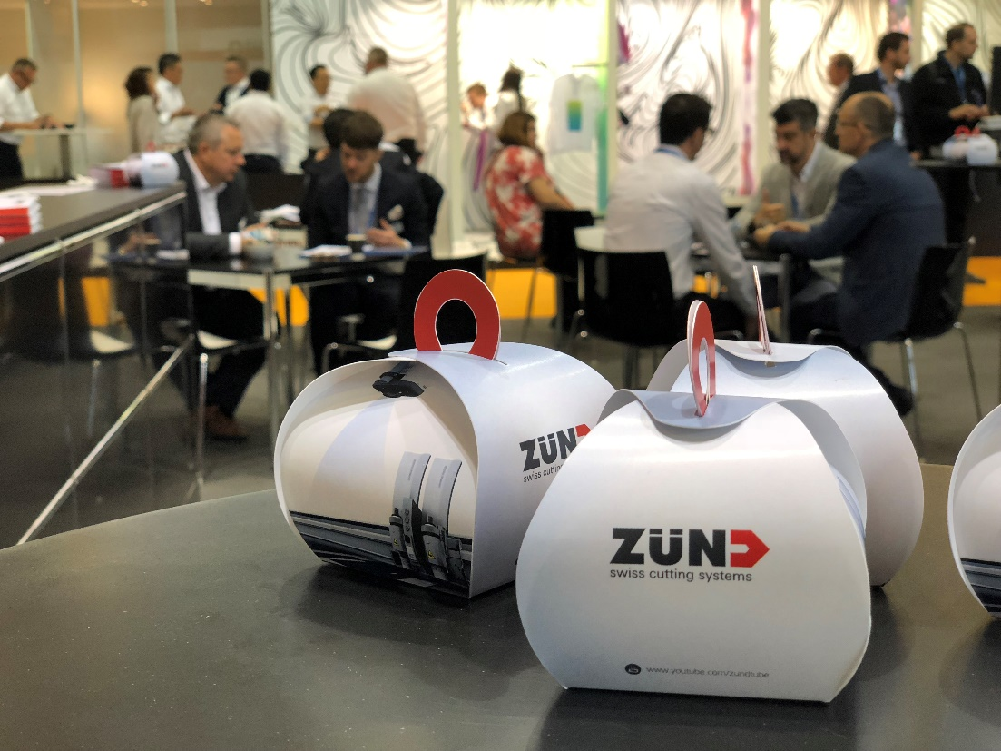

About Zund Systemtechnik AG
Zund Systemtechnik AG, a global, Swiss family company, is the specialist for digital cutting systems. Zund stands for Swiss quality and is synonymous with precision, performance, and reliability. Zund has been building, producing, and marketing modular cutter systems since 1984 and is one of the world's leading manufacturers.
The customers are commercial service providers and industrial companies from the graphics sector, the packaging industry, the clothing and leather sectors, as well as from the textile and composite market. Zund maintains headquarters in Altstätten, Switzerland, where the company’s R&D, marketing, and production facilities are located. Besides Zund's own sales and service organizations in Austria, China, Germany, India, Italy, the Netherlands, Thailand, the United Kingdom, and the United States, Zund relies on a global network of long-standing, independent distribution & service partners.

